Title
Book Management System Using Spring Boot and MongoDB
Project Outcome
The Book Management System successfully automates the process of managing books, students, staff, and departments within an organization. The system provides a centralized platform to perform CRUD operations, issue and return books, search records efficiently, and maintain borrowing history. By integrating Spring Boot with MongoDB, the project demonstrates the implementation of NoSQL database operations, RESTful APIs, and web-based user interaction through Thymeleaf.
The project achieves the following outcomes:
- Efficient management of book records.
- Easy maintenance of student and staff information.
- Faster book issue and return operations.
- Reduced manual effort and data redundancy.
- Demonstration of MongoDB relationships and CRUD operations.
- REST API development and testing using Postman.
- User-friendly web interface using Thymeleaf.
Tools Used
Tool/Technology | Version
Java | 21
Spring Boot | 3.5.x
MongoDB Community Server | 8.x
MongoDB Compass | Latest Version
Apache Maven | 3.9.x
Thymeleaf | 3.x
Postman | Latest Version
VS Code | Latest Version
Git & GitHub | Latest Version
Output Screenshots and Explanation
1. Home Page
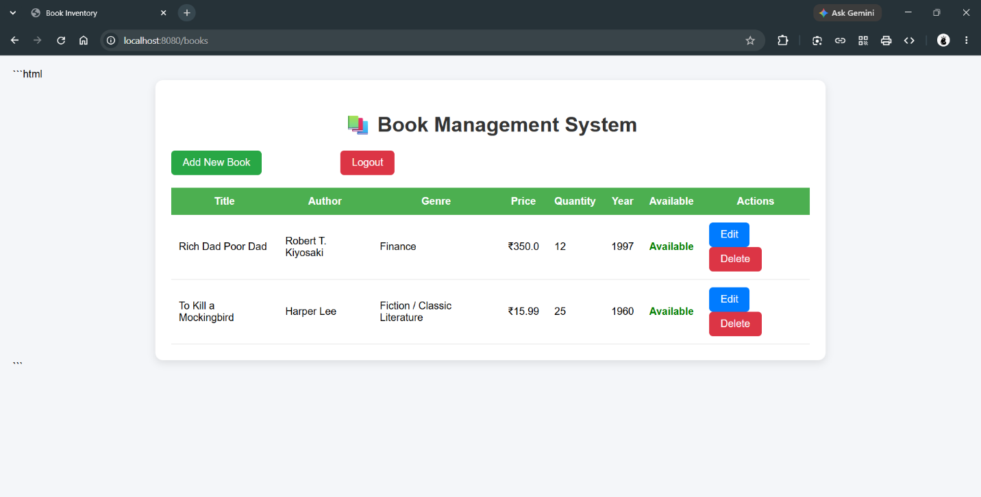
Explanation:
The homepage provides navigation links for managing books, students, staff, and departments. It acts as the central dashboard of the application.
2. Add Book Page
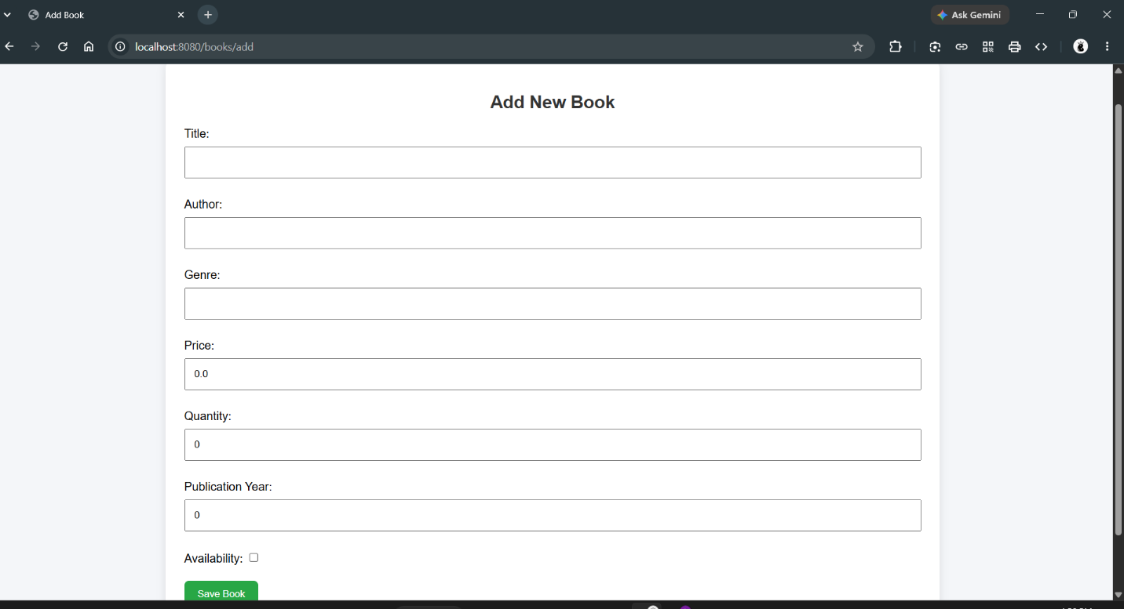
Explanation:
This page allows administrators to add new books by entering details such as title, author, ISBN, category, and available copies. The information is stored in MongoDB.
3. View Books Page
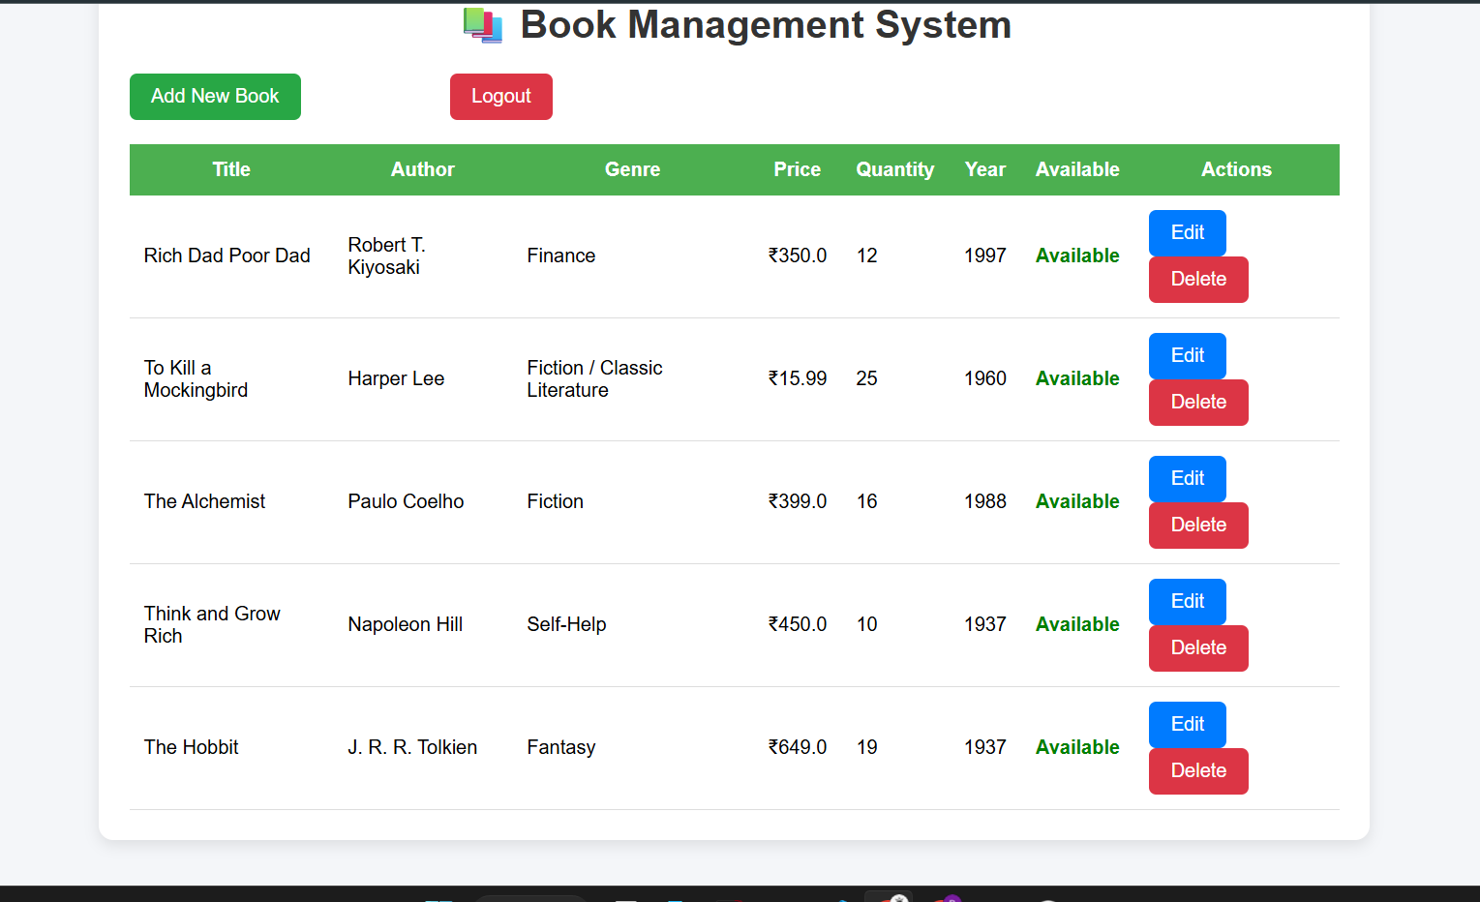Explanation:
Displays all books available in the system. Users can search, edit, or delete books from this page.
10. MongoDB Compass Database
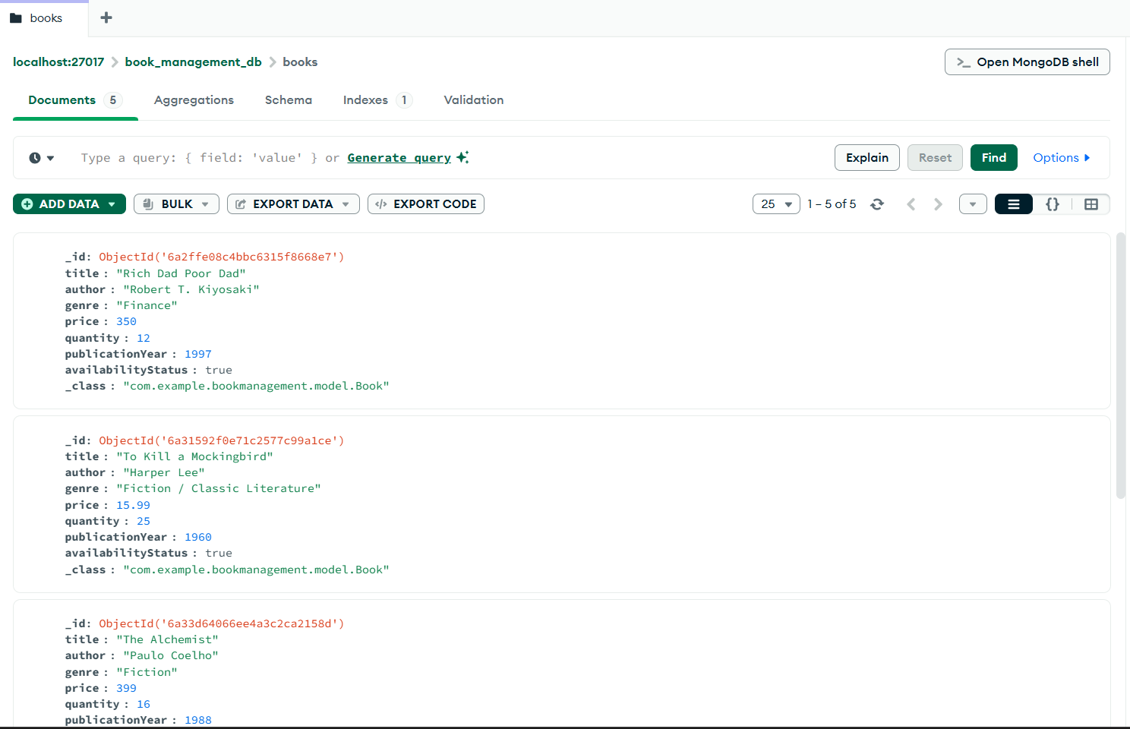
Explanation:
Shows collections such as Books, Students, Staffs, and Departments stored in MongoDB. Demonstrates successful database integration.
11. Postman API Testing
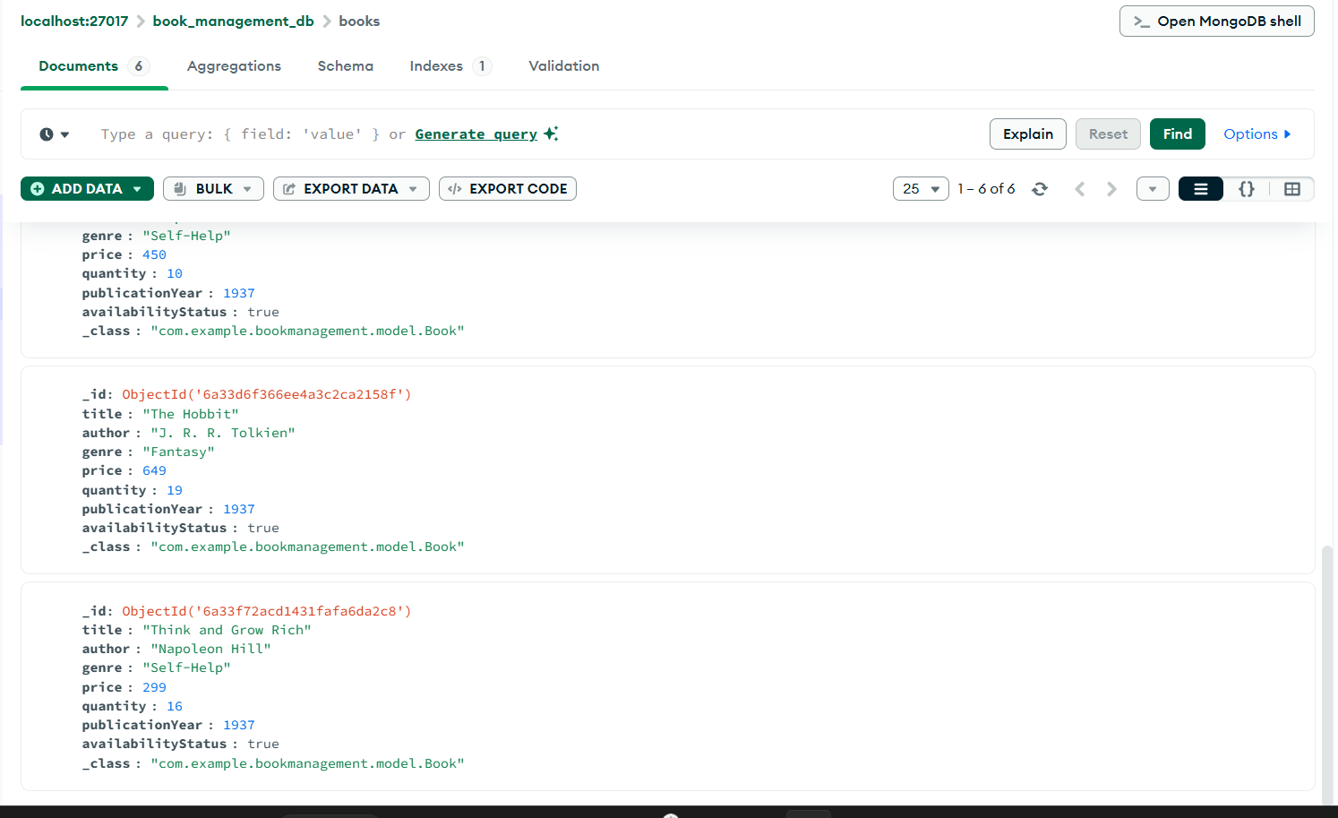
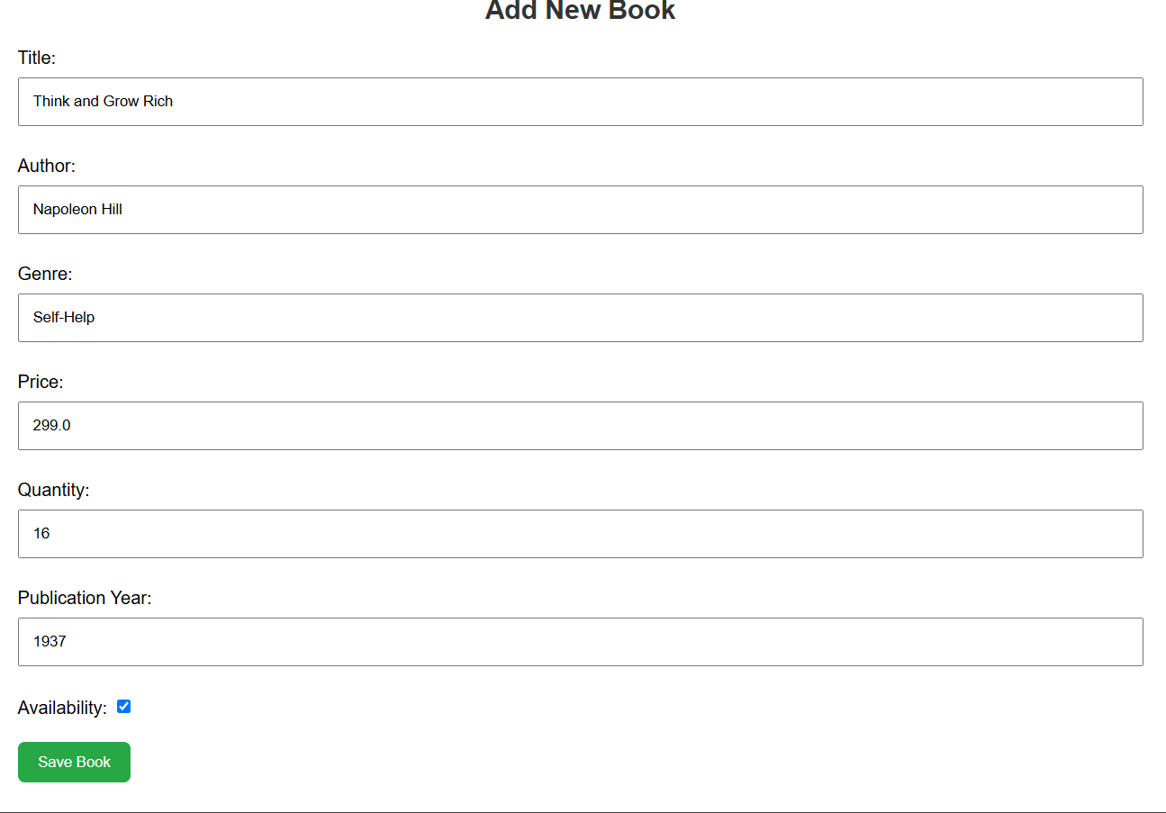

Explanation:
Used to test REST APIs such as GET, POST, PUT, and DELETE operations for all modules.
Summary
The Book Management System is a complete web-based application developed using Spring Boot and MongoDB. The system efficiently manages books, students, staff, and departments while providing advanced features such as searching, issuing, and returning books. MongoDB enables flexible storage of data through collections and document-based structures. Thymeleaf offers an interactive user interface, while Postman and Swagger facilitate API testing and documentation. The project demonstrates practical implementation of modern backend development concepts, database integration, and RESTful services.
Conclusion
The Book Management System successfully fulfills all functional and technical requirements. It demonstrates the use of Spring Boot for backend development, MongoDB for NoSQL data storage, and Thymeleaf for frontend rendering. The application provides an efficient, scalable, and user-friendly solution for managing book-related operations. Through the implementation of CRUD operations, entity relationships, REST APIs, and database integration, the project serves as an industry-oriented application and a strong example of full-stack Java development.

